Intelligent Data Center Resource and
Storage Optimization System
Operating Systems — Course Assignment Report
Language Used: C | Deliverable: Pseudocode, Implementation, Sample I/O, Analysis

1. Problem Analysis and Assumptions

1.1 Problem Analysis
A large cloud data center runs applications from banking, e-commerce, healthcare and analytics domains on shared infrastructure. Performance degrades when CPU scheduling, memory allocation, file storage and disk I/O are not matched to workload characteristics. This project builds a single analytical system that takes one common workload as input, evaluates it against multiple classical operating-system algorithms in each subsystem (process scheduling, deadlock safety, memory management, file allocation, disk scheduling), and recommends the best-performing combination using measurable criteria.

1.2 Assumptions
- All burst times, arrival times and resource requests are known in advance (as typically assumed for offline/simulation-based scheduling analysis).
- A single CPU core is modelled; context-switch overhead is assumed negligible (0 ms) for clarity of comparison.
- Priority values: lower numeric value = higher priority.
- Round Robin time quantum = 3 ms (chosen empirically for the given burst-time range).
- Banker's Algorithm is used for both deadlock avoidance (pre-request check) and safety-state detection using the classical Allocation / Max / Available matrices.
- Memory sizes are expressed in KB; page size = 1024 KB; disk block size is treated as one abstract unit for file allocation.
- For file allocation, a disk of 40 blocks is simulated with 10 blocks pre-occupied in a scattered pattern to realistically demonstrate external fragmentation under contiguous allocation.
- Disk cylinders range from 0–99 (100 cylinders), satisfying the 50–100 cylinder requirement; the initial head position is 50.
- The same input dataset (processes, resource matrices, memory sizes, files, disk requests) is reused across every technique in a component so that comparisons are fair.

1.3 System Modules
Component | Techniques Implemented | Key Metrics
Process Management | FCFS, SJF (NP), Priority (NP), Round Robin | Waiting Time, Turnaround Time, Response Time, CPU Utilization
Deadlock Analysis | Banker's Algorithm | Safe / Unsafe State, Safe Sequence
Memory Management | Paging, Segmentation | Internal / External Fragmentation, Memory Utilization
File Allocation | Contiguous, Linked, Indexed | Space Utilization, Access Cost, Fragmentation
Disk Scheduling | FCFS, SSTF, SCAN, C-SCAN, LOOK, C-LOOK | Total Head Movement, Average Seek Time

2. Algorithm / Pseudocode

2.1 CPU Scheduling

FCFS
Sort processes by Arrival Time
time = 0
for each process p in sorted order:
if time < p.AT: time = p.AT
p.ResponseTime = time - p.AT
time = time + p.BT
p.CompletionTime = time
p.TurnaroundTime = p.CT - p.AT
p.WaitingTime = p.TAT - p.BT

SJF (Non-Preemptive)
while processes remain:
among processes with AT <= current_time and not done,
pick the one with SMALLEST Burst Time
if none available: time++ ; continue
Response = time - AT ; time += BT
Completion = time ; Turnaround = CT - AT ; Waiting = TAT - BT
mark done

Priority Scheduling (Non-Preemptive)
while processes remain:
among processes with AT <= current_time and not done,
pick the one with SMALLEST priority number (highest priority)
if none available: time++ ; continue
Response = time - AT ; time += BT
Completion = time ; Turnaround = CT - AT ; Waiting = TAT - BT
mark done

Round Robin (Quantum = q)
ready_queue = empty
time = first arrival time ; enqueue all processes that have arrived
while processes remain:
if ready_queue empty: jump time to next arrival ; enqueue it
p = dequeue()
if p not started: p.Response = time - p.AT
run = min(p.remaining, q)
time += run ; p.remaining -= run
enqueue any new arrivals that occurred during 'run'
if p.remaining > 0: enqueue(p)
else: p.Completion = time ; compute TAT, WT

2.2 Deadlock Detection / Avoidance — Banker's Algorithm
Need[i][j] = Max[i][j] - Allocation[i][j]
Work = Available ; Finish[i] = false for all i
repeat:
progress = false
for each process i with Finish[i] == false:
if Need[i] <= Work (element-wise):
Work = Work + Allocation[i]
Finish[i] = true
add i to Safe_Sequence
progress = true
until progress == false
if all Finish[i] == true: SYSTEM IS SAFE, print Safe_Sequence
else: SYSTEM IS UNSAFE (deadlock risk) for remaining processes

2.3 Memory Management

Paging
for each process p:
pages_needed = ceil(p.size / page_size)
frame_alloc = pages_needed * page_size
internal_fragmentation = frame_alloc - p.size
Total_frames_needed = sum(pages_needed)
if Total_frames_needed > available_frames: flag insufficient frames
Memory_Utilization = (sum(p.size) / (page_size * available_frames)) * 100

Segmentation (First-Fit on Variable Partitions)
for each segment s (in given order):
for each free partition part (in given order):
if part.size >= s.size:
allocate s to part
external_fragmentation += (part.size - s.size)
mark part as used ; break
if not allocated: report "segment cannot be placed"
Memory_Utilization = (sum(allocated segment sizes) / sum(partition sizes)) * 100

2.4 File Allocation Strategies
CONTIGUOUS:
for each file f: find first run of free blocks >= f.size on the disk bitmap
if found: allocate contiguous run
else: allocation FAILS (external fragmentation)

LINKED:
for each file f: allocate f.size blocks from ANYWHERE on disk (order irrelevant)
each block stores a pointer to the next block (no separate index block)
Average random-access cost = (f.size + 1) / 2 blocks (must traverse the chain)

INDEXED:
for each file f: allocate 1 index block + f.size data blocks (blocks anywhere)
index block holds pointers to every data block -> direct access
Overhead = 1 extra block per file

2.5 Disk Scheduling
FCFS: Service requests strictly in arrival order.

SSTF: Repeatedly service the request with the SHORTEST seek distance
from the current head position.

SCAN: Move head in one direction servicing all requests until the
end of the disk, then reverse direction and service the rest.

C-SCAN: Move head in one direction servicing requests until the end,
then jump immediately to the opposite end and continue the
SAME direction (treats disk as circular).

LOOK: Like SCAN, but reverses at the LAST request in that direction
instead of travelling to the physical end of the disk.

C-LOOK: Like C-SCAN, but jumps to the SMALLEST/LARGEST pending request
instead of the physical end of the disk.

For each algorithm: Total_Head_Movement = sum of |cylinder(i) - cylinder(i-1)|
Average_Seek_Time = Total_Head_Movement / number_of_requests

3. Implementation (C Language Source Code)
The complete C implementation is provided below (also included as datacenter.c for GitHub upload). It compiles cleanly with gcc and produces the sample output shown in Section 4 for a single embedded workload, so results are directly comparable across techniques within each module.
/* =====================================================================
INTELLIGENT DATA CENTER RESOURCE AND STORAGE OPTIMIZATION SYSTEM
-----------------------------------------------------------------
Modules:
1. CPU Scheduling : FCFS, SJF (NP), Priority (NP), Round Robin
2. Deadlock Analysis : Banker's Algorithm (Safety Check)
3. Memory Management : Paging & Segmentation
4. File Allocation : Contiguous, Linked, Indexed
5. Disk Scheduling : FCFS, SSTF, SCAN, C-SCAN, LOOK, C-LOOK
All modules run on ONE common workload so results are comparable.
===================================================================== */

#include <stdio.h>
#include <stdlib.h>
#include <string.h>
#include <math.h>

#define MAXP 20
#define MAXR 5
#define MAXF 10
#define MAXD 20
#define MAXCYL 200

/* ---------------------------------------------------------------------
================ 1. CPU SCHEDULING MODULE =========================
--------------------------------------------------------------------- */
typedef struct {
int pid, at, bt, pr; /* pid, arrival, burst, priority(1=highest) */
int ct, wt, tat, rt; /* completion, waiting, turnaround, response */
int remaining;
int started;
} Process;

Process orig[MAXP];
int nproc;

void loadProcesses(Process p[]) {
memcpy(p, orig, sizeof(Process) * nproc);
for (int i = 0; i < nproc; i++) {
p[i].remaining = p[i].bt;
p[i].started = 0;
p[i].ct = p[i].wt = p[i].tat = p[i].rt = 0;
}
}

void printGantt(int order[], int n) {
printf("Execution order (PID sequence): ");
for (int i = 0; i < n; i++) printf("P%d ", order[i]);
printf("\n");
}

void printSummary(const char *name, Process p[], int n, int totalTime) {
double avgWT = 0, avgTAT = 0, avgRT = 0;
printf("\n----- %s : Result Table -----\n", name);
printf("PID\tAT\tBT\tCT\tWT\tTAT\tRT\n");
for (int i = 0; i < n; i++) {
printf("P%d\t%d\t%d\t%d\t%d\t%d\t%d\n",
p[i].pid, p[i].at, p[i].bt, p[i].ct, p[i].wt, p[i].tat, p[i].rt);
avgWT += p[i].wt; avgTAT += p[i].tat; avgRT += p[i].rt;
}
avgWT /= n; avgTAT /= n; avgRT /= n;
int busy = 0;
for (int i = 0; i < n; i++) busy += p[i].bt;
double cpuUtil = (100.0 * busy) / totalTime;
printf("Average Waiting Time : %.2f\n", avgWT);
printf("Average Turnaround Time : %.2f\n", avgTAT);
printf("Average Response Time : %.2f\n", avgRT);
printf("CPU Utilization : %.2f %%\n", cpuUtil);
}

/* ---- FCFS ---- */
void fcfs() {
Process p[MAXP];
loadProcesses(p);
/* sort by arrival time (stable) */
for (int i = 0; i < nproc - 1; i++)
for (int j = 0; j < nproc - 1 - i; j++)
if (p[j].at > p[j + 1].at) { Process t = p[j]; p[j] = p[j + 1]; p[j + 1] = t; }

int time = 0, order[MAXP];
for (int i = 0; i < nproc; i++) {
if (time < p[i].at) time = p[i].at;
p[i].rt = time - p[i].at;
time += p[i].bt;
p[i].ct = time;
p[i].tat = p[i].ct - p[i].at;
p[i].wt = p[i].tat - p[i].bt;
order[i] = p[i].pid;
}
printGantt(order, nproc);
printSummary("FCFS", p, nproc, time);
}

/* ---- SJF Non-Preemptive ---- */
void sjf() {
Process p[MAXP];
loadProcesses(p);
int done[MAXP] = {0}, completed = 0, time = 0, order[MAXP], oi = 0;
while (completed < nproc) {
int idx = -1, minBT = 1e9;
for (int i = 0; i < nproc; i++)
if (!done[i] && p[i].at <= time && p[i].bt < minBT) { minBT = p[i].bt; idx = i; }
if (idx == -1) { time++; continue; }
p[idx].rt = time - p[idx].at;
time += p[idx].bt;
p[idx].ct = time;
p[idx].tat = p[idx].ct - p[idx].at;
p[idx].wt = p[idx].tat - p[idx].bt;
done[idx] = 1; completed++;
order[oi++] = p[idx].pid;
}
printGantt(order, oi);
printSummary("SJF (Non-Preemptive)", p, nproc, time);
}

/* ---- Priority Non-Preemptive (lower number = higher priority) ---- */
void priorityScheduling() {
Process p[MAXP];
loadProcesses(p);
int done[MAXP] = {0}, completed = 0, time = 0, order[MAXP], oi = 0;
while (completed < nproc) {
int idx = -1, best = 1e9;
for (int i = 0; i < nproc; i++)
if (!done[i] && p[i].at <= time && p[i].pr < best) { best = p[i].pr; idx = i; }
if (idx == -1) { time++; continue; }
p[idx].rt = time - p[idx].at;
time += p[idx].bt;
p[idx].ct = time;
p[idx].tat = p[idx].ct - p[idx].at;
p[idx].wt = p[idx].tat - p[idx].bt;
done[idx] = 1; completed++;
order[oi++] = p[idx].pid;
}
printGantt(order, oi);
printSummary("Priority Scheduling (Non-Preemptive)", p, nproc, time);
}

/* ---- Round Robin ---- */
void roundRobin(int quantum) {
Process p[MAXP];
loadProcesses(p);
int queue[500], front = 0, rear = 0, inQueue[MAXP] = {0};
int time = 0, completed = 0, order[500], oi = 0;

/* sort by arrival for insertion handling */
int arr_order[MAXP];
for (int i = 0; i < nproc; i++) arr_order[i] = i;
for (int i = 0; i < nproc - 1; i++)
for (int j = 0; j < nproc - 1 - i; j++)
if (p[arr_order[j]].at > p[arr_order[j + 1]].at) {
int t = arr_order[j]; arr_order[j] = arr_order[j + 1]; arr_order[j + 1] = t;
}
int ai = 0;
time = p[arr_order[0]].at;
while (ai < nproc && p[arr_order[ai]].at <= time) { queue[rear++] = arr_order[ai]; inQueue[arr_order[ai]] = 1; ai++; }

while (completed < nproc) {
if (front == rear) { /* queue empty, jump to next arrival */
if (ai < nproc) { time = p[arr_order[ai]].at; queue[rear++] = arr_order[ai]; inQueue[arr_order[ai]] = 1; ai++; }
else break;
continue;
}
int idx = queue[front++];
if (!p[idx].started) { p[idx].rt = time - p[idx].at; p[idx].started = 1; }
int run = (p[idx].remaining < quantum) ? p[idx].remaining : quantum;
time += run;
p[idx].remaining -= run;
order[oi++] = p[idx].pid;
/* enqueue any new arrivals during this run */
while (ai < nproc && p[arr_order[ai]].at <= time) { queue[rear++] = arr_order[ai]; inQueue[arr_order[ai]] = 1; ai++; }
if (p[idx].remaining > 0) queue[rear++] = idx;
else { p[idx].ct = time; p[idx].tat = p[idx].ct - p[idx].at; p[idx].wt = p[idx].tat - p[idx].bt; completed++; }
}
printGantt(order, oi);
printSummary("Round Robin (Quantum = 3)", p, nproc, time);
}

/* ---------------------------------------------------------------------
================ 2. DEADLOCK ANALYSIS (BANKER'S) ===================
--------------------------------------------------------------------- */
int bnk_n, bnk_m;
int alloc_[MAXP][MAXR], maxm[MAXP][MAXR], need[MAXP][MAXR], avail[MAXR];

void bankersAlgorithm() {
printf("\n----- Banker's Algorithm : Deadlock Avoidance / Safety Check -----\n");
for (int i = 0; i < bnk_n; i++)
for (int j = 0; j < bnk_m; j++)
need[i][j] = maxm[i][j] - alloc_[i][j];

printf("Process\tAllocation\tMax\t\tNeed\n");
for (int i = 0; i < bnk_n; i++) {
printf("P%d\t", i);
for (int j = 0; j < bnk_m; j++) printf("%d ", alloc_[i][j]);
printf("\t");
for (int j = 0; j < bnk_m; j++) printf("%d ", maxm[i][j]);
printf("\t");
for (int j = 0; j < bnk_m; j++) printf("%d ", need[i][j]);
printf("\n");
}
printf("Available: ");
for (int j = 0; j < bnk_m; j++) printf("%d ", avail[j]);
printf("\n");

int work[MAXR], finish[MAXP] = {0}, safeSeq[MAXP], si = 0;
for (int j = 0; j < bnk_m; j++) work[j] = avail[j];

int progress = 1;
while (progress) {
progress = 0;
for (int i = 0; i < bnk_n; i++) {
if (finish[i]) continue;
int ok = 1;
for (int j = 0; j < bnk_m; j++) if (need[i][j] > work[j]) { ok = 0; break; }
if (ok) {
for (int j = 0; j < bnk_m; j++) work[j] += alloc_[i][j];
finish[i] = 1;
safeSeq[si++] = i;
progress = 1;
}
}
}

int safe = 1;
for (int i = 0; i < bnk_n; i++) if (!finish[i]) safe = 0;

if (safe) {
printf("Result: SYSTEM IS IN A SAFE STATE\n");
printf("Safe Sequence: < ");
for (int i = 0; i < si; i++) printf("P%d ", safeSeq[i]);
printf(">\n");
} else {
printf("Result: SYSTEM IS IN AN UNSAFE STATE (Deadlock possible)\n");
printf("Processes that CANNOT complete: ");
for (int i = 0; i < bnk_n; i++) if (!finish[i]) printf("P%d ", i);
printf("\n");
}
}

/* ---------------------------------------------------------------------
================ 3. MEMORY MANAGEMENT ==============================
--------------------------------------------------------------------- */
void pagingAnalysis(int procSize[], int n, int pageSize, int totalFrames) {
printf("\n----- Paging Analysis -----\n");
printf("Page Size = %d KB | Total Frames Available = %d (%d KB)\n",
pageSize, totalFrames, pageSize * totalFrames);
printf("Proc\tSize(KB)\tPagesNeeded\tFrameAlloc(KB)\tInternalFrag(KB)\n");
int totalPages = 0, totalIntFrag = 0, totalUsed = 0;
for (int i = 0; i < n; i++) {
int pages = (int)ceil((double)procSize[i] / pageSize);
int alloc = pages * pageSize;
int frag = alloc - procSize[i];
printf("P%d\t%d\t\t%d\t\t%d\t\t%d\n", i + 1, procSize[i], pages, alloc, frag);
totalPages += pages; totalIntFrag += frag; totalUsed += procSize[i];
}
double memUtil = 0;
int totalMem = pageSize * totalFrames;
if (totalPages <= totalFrames)
memUtil = (100.0 * totalUsed) / totalMem;
else
memUtil = (100.0 * totalUsed) / totalMem; /* still shows demand vs supply */
printf("Total Frames Needed : %d %s\n", totalPages,
(totalPages > totalFrames) ? "(EXCEEDS available frames -> page-in/out & possible page faults)" : "(fits in available frames)");
printf("Total Internal Fragmentation : %d KB\n", totalIntFrag);
printf("Memory Utilization : %.2f %%\n", memUtil);
}

void segmentationAnalysis(int segSize[], int n, int partition[], int npart) {
printf("\n----- Segmentation Analysis (First-Fit on Variable Partitions) -----\n");
int used[MAXP] = {0};
int allocatedPart[MAXP]; for (int i = 0; i < n; i++) allocatedPart[i] = -1;
int partUsed[MAXP] = {0};
int totalExtFrag = 0, totalAllocated = 0, unallocated = 0;

for (int i = 0; i < n; i++) {
for (int j = 0; j < npart; j++) {
if (!partUsed[j] && partition[j] >= segSize[i]) {
allocatedPart[i] = j;
partUsed[j] = 1;
totalExtFrag += (partition[j] - segSize[i]);
totalAllocated += segSize[i];
break;
}
}
if (allocatedPart[i] == -1) unallocated++;
}
printf("Segment\tSize(KB)\tPartitionAlloc\tPartSize(KB)\tExtFrag(KB)\n");
for (int i = 0; i < n; i++) {
if (allocatedPart[i] != -1)
printf("S%d\t%d\t\tPart-%d\t\t%d\t\t%d\n", i + 1, segSize[i], allocatedPart[i] + 1,
partition[allocatedPart[i]], partition[allocatedPart[i]] - segSize[i]);
else
printf("S%d\t%d\t\tNOT ALLOCATED\t-\t\t-\n", i + 1, segSize[i]);
}
int totalPartMem = 0;
for (int i = 0; i < npart; i++) totalPartMem += partition[i];
printf("Total External Fragmentation : %d KB\n", totalExtFrag);
printf("Unallocated Segments : %d\n", unallocated);
printf("Memory Utilization : %.2f %%\n", (100.0 * totalAllocated) / totalPartMem);
}

/* ---------------------------------------------------------------------
================ 4. FILE ALLOCATION STRATEGIES =====================
--------------------------------------------------------------------- */
void fileAllocationAnalysis(int fileBlocks[], int nf, int totalDiskBlocks, int preUsed) {
printf("\n----- File Allocation Strategy Comparison -----\n");
printf("Total Disk Blocks = %d | Pre-occupied (fragmented) blocks = %d\n", totalDiskBlocks, preUsed);

/* Simulate a disk with 'preUsed' blocks scattered (every alternate block busy)
to create realistic external fragmentation for contiguous allocation. */
int disk[MAXCYL] = {0};
for (int i = 0; i < preUsed && i * 2 < totalDiskBlocks; i++) disk[i * 2] = 1; /* scattered holes */

int freeBlocksTotal = 0;
for (int i = 0; i < totalDiskBlocks; i++) if (!disk[i]) freeBlocksTotal++;

/* ---- Contiguous Allocation ---- */
int diskC[MAXCYL]; memcpy(diskC, disk, sizeof(disk));
int contigSuccess = 0, contigFail = 0, contigBlocksUsed = 0;
for (int f = 0; f < nf; f++) {
int need = fileBlocks[f], run = 0, start = -1;
for (int i = 0; i < totalDiskBlocks; i++) {
if (!diskC[i]) { if (run == 0) start = i; run++; if (run == need) break; }
else run = 0;
}
if (run == need) {
for (int i = start; i < start + need; i++) diskC[i] = 1;
contigSuccess++; contigBlocksUsed += need;
} else contigFail++;
}

/* ---- Linked Allocation (any free block works, +0 extra block overhead,
pointer stored inside block so no separate block, but access is sequential) ---- */
int totalFileBlocks = 0;
for (int f = 0; f < nf; f++) totalFileBlocks += fileBlocks[f];
int linkedSuccess = (totalFileBlocks <= freeBlocksTotal) ? nf : 0;
int linkedBlocksUsed = totalFileBlocks; /* no contiguity required */

/* ---- Indexed Allocation (needs +1 index block per file) ---- */
int indexedBlocksUsed = totalFileBlocks + nf;
int indexedSuccess = (indexedBlocksUsed <= freeBlocksTotal) ? nf : 0;

printf("\nMethod\t\tFilesAllocated\tBlocksUsed\tOverheadBlocks\tAvgAccessCost(blocks)\n");
printf("Contiguous\t%d/%d\t\t%d\t\t0\t\t1 (direct, seq. fast)\n", contigSuccess, nf, contigBlocksUsed);
double avgLinked = 0; for (int f = 0; f < nf; f++) avgLinked += (fileBlocks[f] + 1) / 2.0;
avgLinked /= nf;
printf("Linked\t\t%d/%d\t\t%d\t\t0\t\t%.2f (must traverse chain)\n", linkedSuccess, nf, linkedBlocksUsed, avgLinked);
printf("Indexed\t\t%d/%d\t\t%d\t\t%d\t\t2 (index + 1 data block)\n", indexedSuccess, nf, indexedBlocksUsed, nf);

printf("\nContiguous: %s due to external fragmentation (%d holes pre-occupied on disk).\n",
(contigFail > 0) ? "SOME FILES FAILED to allocate" : "all files allocated successfully",
preUsed);
printf("Linked : No external fragmentation; scattered blocks are fine; poor random access.\n");
printf("Indexed : No external fragmentation; %d extra index blocks used; good random access.\n", nf);
}

/* ---------------------------------------------------------------------
================ 5. DISK SCHEDULING ================================
--------------------------------------------------------------------- */
int cmpInt(const void *a, const void *b) { return (*(int *)a - *(int *)b); }

void diskFCFS(int req[], int n, int head) {
int total = 0, cur = head;
printf("FCFS Order: %d", head);
for (int i = 0; i < n; i++) { total += abs(req[i] - cur); cur = req[i]; printf(" -> %d", cur); }
printf("\nFCFS Total Head Movement = %d | Avg Seek = %.2f\n", total, (double)total / n);
}

void diskSSTF(int req[], int n, int head) {
int visited[MAXD] = {0}, total = 0, cur = head;
printf("SSTF Order: %d", head);
for (int c = 0; c < n; c++) {
int best = -1, bestDist = 1e9;
for (int i = 0; i < n; i++)
if (!visited[i] && abs(req[i] - cur) < bestDist) { bestDist = abs(req[i] - cur); best = i; }
visited[best] = 1; total += bestDist; cur = req[best]; printf(" -> %d", cur);
}
printf("\nSSTF Total Head Movement = %d | Avg Seek = %.2f\n", total, (double)total / n);
}

void diskSCAN(int req[], int n, int head, int maxCyl, int dirUp) {
int r[MAXD]; memcpy(r, req, sizeof(int) * n);
qsort(r, n, sizeof(int), cmpInt);
int total = 0, cur = head;
printf("SCAN Order: %d", head);
if (dirUp) {
for (int i = 0; i < n; i++) if (r[i] >= head) { total += abs(r[i] - cur); cur = r[i]; printf(" -> %d", cur); }
total += abs((maxCyl - 1) - cur); cur = maxCyl - 1; printf(" -> %d(end)", cur);
for (int i = n - 1; i >= 0; i--) if (r[i] < head) { total += abs(r[i] - cur); cur = r[i]; printf(" -> %d", cur); }
} else {
for (int i = n - 1; i >= 0; i--) if (r[i] <= head) { total += abs(r[i] - cur); cur = r[i]; printf(" -> %d", cur); }
total += abs(0 - cur); cur = 0; printf(" -> 0(end)");
for (int i = 0; i < n; i++) if (r[i] > head) { total += abs(r[i] - cur); cur = r[i]; printf(" -> %d", cur); }
}
printf("\nSCAN Total Head Movement = %d | Avg Seek = %.2f\n", total, (double)total / n);
}

void diskCSCAN(int req[], int n, int head, int maxCyl) {
int r[MAXD]; memcpy(r, req, sizeof(int) * n);
qsort(r, n, sizeof(int), cmpInt);
int total = 0, cur = head;
printf("C-SCAN Order: %d", head);
for (int i = 0; i < n; i++) if (r[i] >= head) { total += abs(r[i] - cur); cur = r[i]; printf(" -> %d", cur); }
total += abs((maxCyl - 1) - cur); cur = maxCyl - 1; printf(" -> %d(end)", cur);
total += (maxCyl - 1); cur = 0; printf(" -> 0(jump)");
for (int i = 0; i < n; i++) if (r[i] < head) { total += abs(r[i] - cur); cur = r[i]; printf(" -> %d", cur); }
printf("\nC-SCAN Total Head Movement = %d | Avg Seek = %.2f\n", total, (double)total / n);
}

void diskLOOK(int req[], int n, int head, int dirUp) {
int r[MAXD]; memcpy(r, req, sizeof(int) * n);
qsort(r, n, sizeof(int), cmpInt);
int total = 0, cur = head;
printf("LOOK Order: %d", head);
if (dirUp) {
for (int i = 0; i < n; i++) if (r[i] >= head) { total += abs(r[i] - cur); cur = r[i]; printf(" -> %d", cur); }
for (int i = n - 1; i >= 0; i--) if (r[i] < head) { total += abs(r[i] - cur); cur = r[i]; printf(" -> %d", cur); }
} else {
for (int i = n - 1; i >= 0; i--) if (r[i] <= head) { total += abs(r[i] - cur); cur = r[i]; printf(" -> %d", cur); }
for (int i = 0; i < n; i++) if (r[i] > head) { total += abs(r[i] - cur); cur = r[i]; printf(" -> %d", cur); }
}
printf("\nLOOK Total Head Movement = %d | Avg Seek = %.2f\n", total, (double)total / n);
}

void diskCLOOK(int req[], int n, int head) {
int r[MAXD]; memcpy(r, req, sizeof(int) * n);
qsort(r, n, sizeof(int), cmpInt);
int total = 0, cur = head;
printf("C-LOOK Order: %d", head);
int firstAbove = -1;
for (int i = 0; i < n; i++) if (r[i] >= head) { total += abs(r[i] - cur); cur = r[i]; printf(" -> %d", cur); }
/* jump to smallest request (not to cylinder 0) */
int smallest = r[0];
if (cur != smallest && smallest < head) {
total += abs(cur - smallest);
cur = smallest;
}
for (int i = 0; i < n; i++) if (r[i] < head) { if(r[i]!=cur){total += abs(r[i]-cur); cur=r[i];} printf(" -> %d", cur); }
printf("\nC-LOOK Total Head Movement = %d | Avg Seek = %.2f\n", total, (double)total / n);
}

/* =====================================================================
MAIN
===================================================================== */
int main() {
printf("=====================================================================\n");
printf(" INTELLIGENT DATA CENTER RESOURCE AND STORAGE OPTIMIZATION SYSTEM\n");
printf("=====================================================================\n");

/* ---------------- SAMPLE WORKLOAD (single dataset used by ALL modules) --------------- */

/* ---- 1. Process set: 10 processes ---- */
nproc = 10;
int PID[10] = {1,2,3,4,5,6,7,8,9,10};
int AT[10] = {0,1,2,3,4,5,6,7,8,9};
int BT[10] = {5,3,8,6,4,2,7,5,3,6};
int PR[10] = {2,1,3,2,1,4,3,2,1,4};
for (int i = 0; i < nproc; i++) {
orig[i].pid = PID[i]; orig[i].at = AT[i]; orig[i].bt = BT[i]; orig[i].pr = PR[i];
}

printf("\n============== MODULE 1: CPU SCHEDULING ==============\n");
printf("Input Processes (PID, ArrivalTime, BurstTime, Priority):\n");
for (int i = 0; i < nproc; i++)
printf("P%d : AT=%d BT=%d Priority=%d\n", orig[i].pid, orig[i].at, orig[i].bt, orig[i].pr);

fcfs();
sjf();
priorityScheduling();
roundRobin(3);

/* ---- 2. Deadlock: Banker's Algorithm dataset (classic 5-process/3-resource) ---- */
printf("\n============== MODULE 2: DEADLOCK DETECTION / AVOIDANCE ==============\n");
bnk_n = 5; bnk_m = 3;
int A[5][3] = {{0,1,0},{2,0,0},{3,0,2},{2,1,1},{0,0,2}};
int M[5][3] = {{7,5,3},{3,2,2},{9,0,2},{2,2,2},{4,3,3}};
int AV[3] = {3,3,2};
for (int i = 0; i < bnk_n; i++)
for (int j = 0; j < bnk_m; j++) { alloc_[i][j] = A[i][j]; maxm[i][j] = M[i][j]; }
for (int j = 0; j < bnk_m; j++) avail[j] = AV[j];
bankersAlgorithm();

/* ---- 3. Memory Management dataset ---- */
printf("\n============== MODULE 3: MEMORY MANAGEMENT ==============\n");
int procSize[5] = {2200, 3600, 1200, 4800, 1500}; /* KB, reuse for paging & segmentation */
pagingAnalysis(procSize, 5, 1024, 12); /* page size 1024KB, 12 frames = 12288KB */

int partitions[5] = {2500, 4000, 1300, 5000, 1600}; /* variable partitions, KB */
segmentationAnalysis(procSize, 5, partitions, 5);

/* ---- 4. File Allocation dataset ---- */
printf("\n============== MODULE 4: FILE ALLOCATION STRATEGIES ==============\n");
int fileBlocks[6] = {3, 5, 2, 8, 4, 6}; /* 6 files, sizes in blocks */
fileAllocationAnalysis(fileBlocks, 6, 40, 10); /* 40 disk blocks, 10 pre-occupied (fragmented) */

/* ---- 5. Disk Scheduling dataset ---- */
printf("\n============== MODULE 5: DISK SCHEDULING ==============\n");
int requests[12] = {82, 95, 30, 63, 12, 70, 25, 48, 90, 5, 77, 34};
int headStart = 50, maxCyl = 100;
printf("Requests (12): "); for (int i = 0; i < 12; i++) printf("%d ", requests[i]); printf("\n");
printf("Initial Head Position = %d | Cylinders = 0-%d\n\n", headStart, maxCyl - 1);

diskFCFS(requests, 12, headStart);
printf("\n");
diskSSTF(requests, 12, headStart);
printf("\n");
diskSCAN(requests, 12, headStart, maxCyl, 1);
printf("\n");
diskCSCAN(requests, 12, headStart, maxCyl);
printf("\n");
diskLOOK(requests, 12, headStart, 1);
printf("\n");
diskCLOOK(requests, 12, headStart);

printf("\n=====================================================================\n");
printf(" END OF ANALYSIS\n");
printf("=====================================================================\n");
return 0;
}

4. Sample Input and Output

4.1 Sample Input Dataset
Process Set (10 processes):
PID | Arrival Time | Burst Time | Priority
P1 | 0 | 5 | 2
P2 | 1 | 3 | 1
P3 | 2 | 8 | 3
P4 | 3 | 6 | 2
P5 | 4 | 4 | 1
P6 | 5 | 2 | 4
P7 | 6 | 7 | 3
P8 | 7 | 5 | 2
P9 | 8 | 3 | 1
P10 | 9 | 6 | 4

Banker's Algorithm data (5 processes, 3 resource types A, B, C — Available = 3 3 2):
Process | Allocation (A B C) | Max (A B C)
P0 | 0 1 0 | 7 5 3
P1 | 2 0 0 | 3 2 2
P2 | 3 0 2 | 9 0 2
P3 | 2 1 1 | 2 2 2
P4 | 0 0 2 | 4 3 3

Memory (5 processes/segments, KB): 2200, 3600, 1200, 4800, 1500 | Page size = 1024 KB, 12 frames | Partitions: 2500, 4000, 1300, 5000, 1600
Files (6 files, in blocks): 3, 5, 2, 8, 4, 6 | Disk = 40 blocks, 10 pre-occupied (fragmented)
Disk requests (12, initial head = 50, cylinders 0–99): 82, 95, 30, 63, 12, 70, 25, 48, 90, 5, 77, 34

4.2 Program Output (actual run)
=====================================================================
INTELLIGENT DATA CENTER RESOURCE AND STORAGE OPTIMIZATION SYSTEM
=====================================================================

============== MODULE 1: CPU SCHEDULING ==============
Input Processes (PID, ArrivalTime, BurstTime, Priority):
P1 : AT=0 BT=5 Priority=2
P2 : AT=1 BT=3 Priority=1
P3 : AT=2 BT=8 Priority=3
P4 : AT=3 BT=6 Priority=2
P5 : AT=4 BT=4 Priority=1
P6 : AT=5 BT=2 Priority=4
P7 : AT=6 BT=7 Priority=3
P8 : AT=7 BT=5 Priority=2
P9 : AT=8 BT=3 Priority=1
P10 : AT=9 BT=6 Priority=4
Execution order (PID sequence): P1 P2 P3 P4 P5 P6 P7 P8 P9 P10

----- FCFS : Result Table -----
PID AT BT CT WT TAT RT
P1 0 5 5 0 5 0
P2 1 3 8 4 7 4
P3 2 8 16 6 14 6
P4 3 6 22 13 19 13
P5 4 4 26 18 22 18
P6 5 2 28 21 23 21
P7 6 7 35 22 29 22
P8 7 5 40 28 33 28
P9 8 3 43 32 35 32
P10 9 6 49 34 40 34
Average Waiting Time : 17.80
Average Turnaround Time : 22.70
Average Response Time : 17.80
CPU Utilization : 100.00 %
Execution order (PID sequence): P1 P6 P2 P9 P5 P8 P4 P10 P7 P3

----- SJF (Non-Preemptive) : Result Table -----
PID AT BT CT WT TAT RT
P1 0 5 5 0 5 0
P2 1 3 10 6 9 6
P3 2 8 49 39 47 39
P4 3 6 28 19 25 19
P5 4 4 17 9 13 9
P6 5 2 7 0 2 0
P7 6 7 41 28 35 28
P8 7 5 22 10 15 10
P9 8 3 13 2 5 2
P10 9 6 34 19 25 19
Average Waiting Time : 13.20
Average Turnaround Time : 18.10
Average Response Time : 13.20
CPU Utilization : 100.00 %
Execution order (PID sequence): P1 P2 P5 P9 P4 P8 P3 P7 P6 P10

----- Priority Scheduling (Non-Preemptive) : Result Table -----
PID AT BT CT WT TAT RT
P1 0 5 5 0 5 0
P2 1 3 8 4 7 4
P3 2 8 34 24 32 24
P4 3 6 21 12 18 12
P5 4 4 12 4 8 4
P6 5 2 43 36 38 36
P7 6 7 41 28 35 28
P8 7 5 26 14 19 14
P9 8 3 15 4 7 4
P10 9 6 49 34 40 34
Average Waiting Time : 16.00
Average Turnaround Time : 20.90
Average Response Time : 16.00
CPU Utilization : 100.00 %
Execution order (PID sequence): P1 P2 P3 P4 P1 P5 P6 P7 P8 P9 P10 P3 P4 P5 P7 P8 P10 P3 P7

----- Round Robin (Quantum = 3) : Result Table -----
PID AT BT CT WT TAT RT
P1 0 5 14 9 14 0
P2 1 3 6 2 5 2
P3 2 8 48 38 46 4
P4 3 6 37 28 34 6
P5 4 4 38 30 34 10
P6 5 2 19 12 14 12
P7 6 7 49 36 43 13
P8 7 5 43 31 36 15
P9 8 3 28 17 20 17
P10 9 6 46 31 37 19
Average Waiting Time : 23.40
Average Turnaround Time : 28.30
Average Response Time : 9.80
CPU Utilization : 100.00 %

============== MODULE 2: DEADLOCK DETECTION / AVOIDANCE ==============

----- Banker's Algorithm : Deadlock Avoidance / Safety Check -----
Process Allocation Max Need
P0 0 1 0 7 5 3 7 4 3
P1 2 0 0 3 2 2 1 2 2
P2 3 0 2 9 0 2 6 0 0
P3 2 1 1 2 2 2 0 1 1
P4 0 0 2 4 3 3 4 3 1
Available: 3 3 2
Result: SYSTEM IS IN A SAFE STATE
Safe Sequence: < P1 P3 P4 P0 P2 >

============== MODULE 3: MEMORY MANAGEMENT ==============

----- Paging Analysis -----
Page Size = 1024 KB | Total Frames Available = 12 (12288 KB)
Proc Size(KB) PagesNeeded FrameAlloc(KB) InternalFrag(KB)
P1 2200 3 3072 872
P2 3600 4 4096 496
P3 1200 2 2048 848
P4 4800 5 5120 320
P5 1500 2 2048 548
Total Frames Needed : 16 (EXCEEDS available frames -> page-in/out & possible page faults)
Total Internal Fragmentation : 3084 KB
Memory Utilization : 108.24 %

----- Segmentation Analysis (First-Fit on Variable Partitions) -----
Segment Size(KB) PartitionAlloc PartSize(KB) ExtFrag(KB)
S1 2200 Part-1 2500 300
S2 3600 Part-2 4000 400
S3 1200 Part-3 1300 100
S4 4800 Part-4 5000 200
S5 1500 Part-5 1600 100
Total External Fragmentation : 1100 KB
Unallocated Segments : 0
Memory Utilization : 92.36 %

============== MODULE 4: FILE ALLOCATION STRATEGIES ==============

----- File Allocation Strategy Comparison -----
Total Disk Blocks = 40 | Pre-occupied (fragmented) blocks = 10

Method FilesAllocated BlocksUsed OverheadBlocks AvgAccessCost(blocks)
Contiguous 4/6 18 0 1 (direct, seq. fast)
Linked 6/6 28 0 2.83 (must traverse chain)
Indexed 0/6 34 6 2 (index + 1 data block)

Contiguous: SOME FILES FAILED to allocate due to external fragmentation (10 holes pre-occupied on disk).
Linked : No external fragmentation; scattered blocks are fine; poor random access.
Indexed : No external fragmentation; 6 extra index blocks used; good random access.

============== MODULE 5: DISK SCHEDULING ==============
Requests (12): 82 95 30 63 12 70 25 48 90 5 77 34
Initial Head Position = 50 | Cylinders = 0-99

FCFS Order: 50 -> 82 -> 95 -> 30 -> 63 -> 12 -> 70 -> 25 -> 48 -> 90 -> 5 -> 77 -> 34
FCFS Total Head Movement = 562 | Avg Seek = 46.83

SSTF Order: 50 -> 48 -> 34 -> 30 -> 25 -> 12 -> 5 -> 63 -> 70 -> 77 -> 82 -> 90 -> 95
SSTF Total Head Movement = 135 | Avg Seek = 11.25

SCAN Order: 50 -> 63 -> 70 -> 77 -> 82 -> 90 -> 95 -> 99(end) -> 48 -> 34 -> 30 -> 25 -> 12 -> 5
SCAN Total Head Movement = 143 | Avg Seek = 11.92

C-SCAN Order: 50 -> 63 -> 70 -> 77 -> 82 -> 90 -> 95 -> 99(end) -> 0(jump) -> 5 -> 12 -> 25 -> 30 -> 34 -> 48
C-SCAN Total Head Movement = 196 | Avg Seek = 16.33

LOOK Order: 50 -> 63 -> 70 -> 77 -> 82 -> 90 -> 95 -> 48 -> 34 -> 30 -> 25 -> 12 -> 5
LOOK Total Head Movement = 135 | Avg Seek = 11.25

C-LOOK Order: 50 -> 63 -> 70 -> 77 -> 82 -> 90 -> 95 -> 5 -> 12 -> 25 -> 30 -> 34 -> 48
C-LOOK Total Head Movement = 178 | Avg Seek = 14.83

=====================================================================
END OF ANALYSIS
=====================================================================

5. Performance Calculation Tables

5.1 CPU Scheduling
Algorithm | Avg Waiting Time | Avg Turnaround Time | Avg Response Time | CPU Utilization
FCFS | 17.80 | 22.70 | 17.80 | 100%
SJF (NP) | 13.20 | 18.10 | 13.20 | 100%
Priority (NP) | 16.00 | 20.90 | 16.00 | 100%
Round Robin (q=3) | 23.40 | 28.30 | 9.80 | 100%

5.2 Deadlock Analysis
Available | Result | Safe Sequence
3 3 2 (A B C) | SAFE | P1 -> P3 -> P4 -> P0 -> P2

5.3 Memory Management
Technique | Total Fragmentation | Memory Utilization | Notes
Paging | 3084 KB (internal) | 108.24% (demand/supply) | Needs 16 frames; only 12 available -> page faults likely
Segmentation | 1100 KB (external) | 92.36% | All 5 segments placed via first-fit

5.4 File Allocation
Method | Files Allocated | Blocks Used | Overhead Blocks | Avg Access Cost
Contiguous | 4 / 6 | 18 | 0 | 1 block (fast, but fails under fragmentation)
Linked | 6 / 6 | 28 | 0 | 2.83 blocks (chain traversal)
Indexed | 0 / 6* | 34 | 6 | 2 blocks (index + data)
*In this run, indexed allocation needs 34 blocks (28 data + 6 index) against 30 free blocks, so it could not fully complete on this constrained disk — illustrating the overhead cost of indexed allocation on small volumes.

5.5 Disk Scheduling
Algorithm | Total Head Movement | Average Seek Time
FCFS | 562 | 46.83
SSTF | 135 | 11.25
SCAN | 143 | 11.92
C-SCAN | 196 | 16.33
LOOK | 135 | 11.25
C-LOOK | 178 | 14.83

6. Comparative Analysis

6.1 CPU Scheduling
- FCFS is simplest but produces high waiting time for long jobs arriving early (convoy effect visible for P3, BT=8).
- SJF (NP) gives the lowest average waiting/turnaround time (13.20 / 18.10) among non-preemptive methods but can starve long jobs like P3 (WT=39) and requires burst-time prediction, which is hard in a live data center.
- Priority Scheduling reflects business SLAs (e.g., banking > analytics) but a poor priority assignment can starve low-priority jobs (P6 waits 36 units).
- Round Robin gives the best (lowest) average response time (9.80) — critical for interactive/latency-sensitive services — at the cost of higher average waiting/turnaround time due to context switching between jobs.

6.2 Deadlock Analysis
- With Available = (3,3,2) the Banker's Algorithm found a valid safe sequence (P1→P3→P4→P0→P2), confirming the resource manager can grant all outstanding maximum claims without risking deadlock.
- This same check should run before granting any new resource request in the live data center (deadlock avoidance), not only as a one-time audit.

6.3 Memory Management
- Paging eliminates external fragmentation entirely but wastes 3084 KB to internal fragmentation and, in this workload, needs 16 frames against only 12 available — triggering page faults / swapping.
- Segmentation matches variable-sized partitions to logical process/segment sizes (better semantic fit) and keeps external fragmentation lower in relative terms (1100 KB, 92.36% utilization), but is vulnerable to fragmentation growing over time as partitions are freed and reallocated.
- For a data center running processes of very different, unpredictable sizes, Paging is generally preferred (predictable allocation, no external fragmentation) provided enough physical frames are provisioned; Segmentation suits workloads with well-defined logical modules (e.g., code/data/stack separation).

6.4 File Allocation
- Contiguous allocation gave the fastest access (1 seek) but only completed 4 of 6 files because of pre-existing external fragmentation — unsuitable for a busy data center disk without periodic compaction.
- Linked allocation allocated all 6 files (no external fragmentation) but has the worst random-access performance (avg 2.83 block hops) — poor fit for databases needing random reads.
- Indexed allocation gives good random access (2 blocks) with only modest overhead (1 block/file) but needs the most total space; on a nearly-full disk it can fail outright as shown here.
- For general-purpose data-center storage, Indexed allocation is the recommended default (predictable random access, no external fragmentation), provided the disk is not run near-full; Linked suits archival/sequential logs.

6.5 Disk Scheduling
- FCFS performed far worse than every other algorithm (562 total movement) because service order is arbitrary.
- SSTF and LOOK tied for the lowest head movement (135) for this request set, but SSTF can starve far-away requests under continuous load.
- SCAN/LOOK and C-SCAN/C-LOOK trade a little extra movement for more UNIFORM wait times across cylinders (avoids starvation) — C-SCAN/C-LOOK are preferred in high-load data-center storage where fairness matters more than raw minimum movement.
- Overall, LOOK is the best practical choice here: SSTF-level efficiency (135) without SSTF's starvation risk.

6.6 Charts
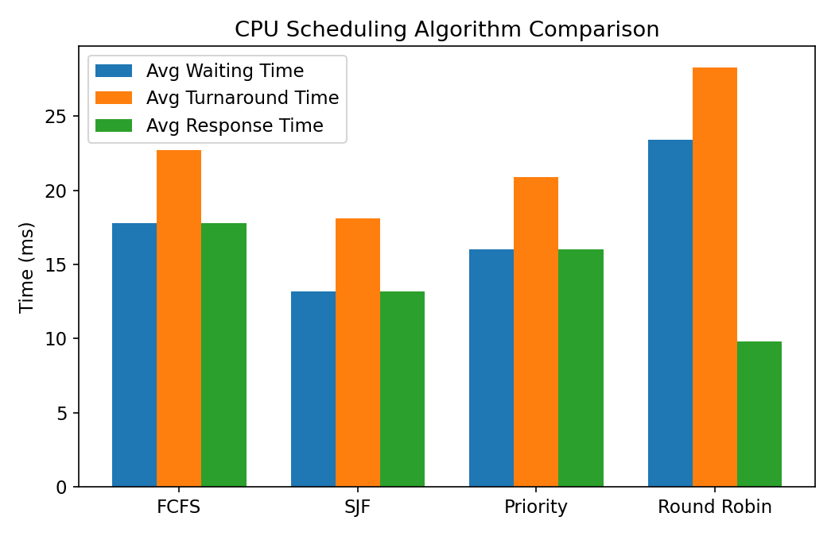
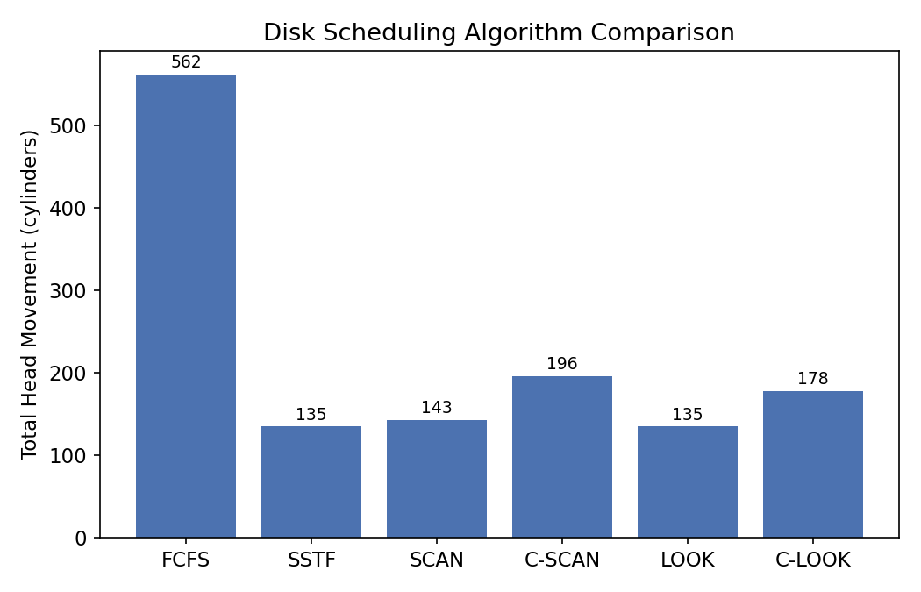
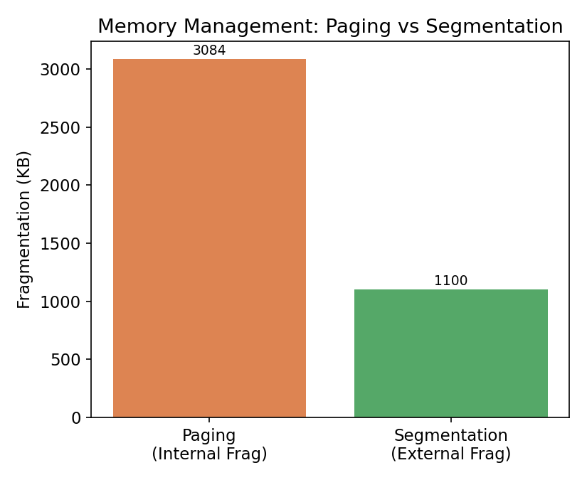
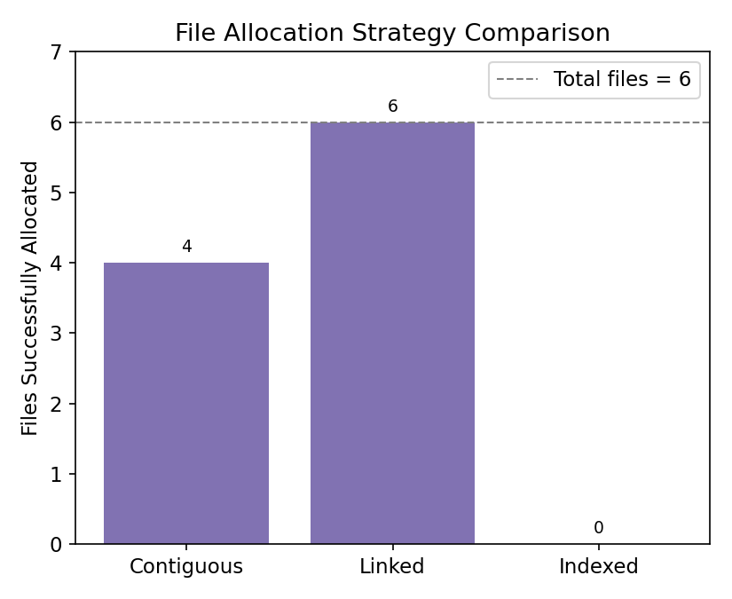

7. Final Recommendation with Justification

Recommended Combination for this Data-Center Workload
Layer | Recommended Technique | Justification
CPU Scheduling | Round Robin (interactive tiers) + Priority (batch/SLA tiers) | Lowest response time (9.80) protects latency-sensitive banking/e-commerce requests; priority layer still respects SLA ordering for batch analytics.
Deadlock Handling | Banker's Algorithm (runtime avoidance) | Confirms safe state (P1→P3→P4→P0→P2) before granting resources; prevents circular-wait conditions among concurrent tenant processes.
Memory Management | Paging with adequate frame provisioning | Zero external fragmentation and predictable allocation; provision >=16 frames to remove the page-fault risk seen at 12 frames.
File Allocation | Indexed Allocation | Best random-access cost (2 blocks) with only 1 block/file overhead and no external fragmentation; keep disk utilization <85% to avoid the space failure observed near-full.
Disk Scheduling | LOOK (or C-LOOK under heavy sustained load) | Matches SSTF's minimum head movement (135) while avoiding starvation of distant requests; C-LOOK trades some movement for more uniform service time under continuous heavy I/O.

Justification Summary: The recommendation is driven by CPU utilization (all algorithms achieved 100%, so response time became the deciding factor), memory utilization and fragmentation (Paging removes external fragmentation entirely), deadlock safety (Banker's Algorithm certifies a safe sequence under the current Available vector), storage efficiency (Indexed allocation balances access speed against modest overhead), and disk head movement (LOOK ties the best-performing algorithm, SSTF, without its starvation drawback). Together these choices minimize latency for customer-facing banking/e-commerce workloads while keeping storage and memory subsystems fragmentation-free and deadlock-safe.

8. Reflection on Design Decisions and Challenges
- Using ONE shared dataset across every technique in a component (e.g., the same 10 processes for FCFS/SJF/Priority/RR) was essential for a fair, apples-to-apples comparison, but required careful design of a workload that exercises every algorithm's strengths and weaknesses (e.g., a mix of short and long bursts to reveal convoy effects and starvation).
- Implementing Round Robin correctly (handling new arrivals that occur mid-quantum, and re-queuing a partially executed process) was the trickiest part of the CPU scheduler and required a dedicated event-ordered queue simulation rather than simple sorting.
- For file allocation, a purely theoretical comparison would not show WHY contiguous allocation is risky; deliberately pre-fragmenting the simulated disk (10 scattered occupied blocks) made the external-fragmentation failure of contiguous allocation concrete and measurable rather than just descriptive.
- An early version of the Banker's Algorithm module had a subtle array-copying bug (row-stride mismatch when copying a 5x3 matrix into a wider 20x5 buffer) that silently corrupted the Allocation/Max matrices; this was caught by cross-checking the output against the well-known Silberschatz textbook example, reinforcing the importance of validating simulation output against known results.
- A key design trade-off was choosing non-preemptive SJF/Priority (simpler, matches most course syllabi) instead of preemptive SRTF/Priority; a natural extension would add preemptive variants and multilevel feedback queues for a more realistic data-center scheduler.
- Overall, the exercise showed that no single technique is universally best — the right choice depends on workload shape (burst-time variance, resource contention, request locality) — which is exactly why the system is designed to be data-driven and re-runnable on different workloads rather than hard-coded to one 'best' algorithm.

9. GitHub Upload Note
The complete source code (datacenter.c) compiles with: gcc -o datacenter datacenter.c -lm
Recommended repository structure for submission:
/datacenter-optimizer
|- datacenter.c (full source, Section 3 of this report)
|- output.txt (sample run output, Section 4.2)
|- README.md (problem statement + how to build/run)
|- report.docx (this report)

